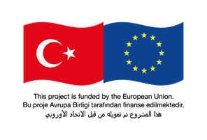
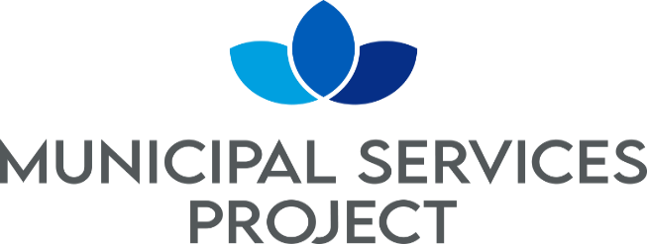

Request for Bids
Small Works
(One-Envelope Bidding Process)

Country: TÜRKİYE
Name of Project: Municipal Services Project-I
Contract Title: Construction of Sanliurfa Birecik WWTP
Loan No./Credit No./ Grant No.: CTR 1075 01 K
RFB Reference No.: AFD SUSKI W3

- In the capacity of Financial Support Programe for Refugeesin Turkey (FRIT 2) funded by EU and delegated to French Development Agency (“AFD”), İLBANK supplied fundingto meet the cost of Municipal Services Project –I. ILBANK intends to apply part of the proceeds toward payments under the contract for the Construction of Sanliurfa Birecik WWTP.

- SUSKI, now invites sealed Bids from eligible Bidders for the construction of below items in Construction of Sanliurfa Birecik WWTP whose contract duration will be 24 months construction and 12 months for defects Liability Period.

The works within the scope of this Agreement are as follows:

The construction of a wastewater treatment plant with a capacity of 12,360 m³/day average waste water flow rate in Birecik (Şanlıurfa).

The definitions and descriptions of the Works and Transactions are specified in the Specifications, Design Files, Site Lists and Unit Price Poses that are annexed to the contract.

Quantities based on production are specified in the Unit Price Offer Table. The Contractor shall consider the quantities in the Unit Price Offer table.

In line with the information given in all documents, it is essential that all facilities within the scope of the work are fully and completely constructed and ready for operation.

- Bidding will be conducted through international competitive procurement using a Request for Bids (RFB) as specified in the AFD’s “Procurement Guidelines for AFD-Financed Contracts in Foreign Countries” October 2019 (“Procurement Regulations”), and is open to all Bidders as defined in the Procurement Regulations.

Interested eligible Bidders may obtain further information from SUSKI, (s.dişli@suski.gov.tr) and inspect the bidding document during office hours 09:00 to 17:00 hoursat the address given below.

- The bidding document in Turkish may be purchased by interested eligible Bidders upon the submission of a written application to the address below and upon payment of a nonrefundable fee of 5.000,00 TL. The method of payment will be direct deposit to bank account number TR 190001002266680384695005 mentioning the payment is for AFD SUSKI W3. The bidding document will be sent via courier, hand delivery or by e-mail.

- Bids must be delivered to the address below on or before 14:00 and 14/06/2024 Electronic Bidding will will not be permitted. Late Bids will be rejected. Bids will be publicly opened in the presence of the Bidders’ designated representatives and anyone who chooses to attend at the address below on 14:30 and 14/06/2024

- All Bids must be accompanied by a “Bid Security” of 275.000 EUR or equivalent

- The addresses referred to above are:

Place for obtaining further information regarding the bid documents, requesting clarifications and submitting bids:

For the attention of: Sanliurfa Metropolitan Municipality, DG of SUSKI
Address: Ertugrul Gazi Mah. Necip Fazıl Kısakurek Cad. No:35/C Haliliye
City: Sanliurfa
Country: Türkiye
Tel: +90 414 318 45 55
GSM: 0544 477 63 50
Fax: +90 414 318 45 55
E-mail: s.dişli@suski.gov.tr
Place for opening of bids:
Address: ​ Ertugrul Gazi Mah. Necip Fazıl Kısakurek Cad. No:35/C Haliliye
City: ​ Sanliurfa
Country: Türkiye

Please see Bidding document, Section II Bid Data Sheet (BDS), ITB 19.1.

